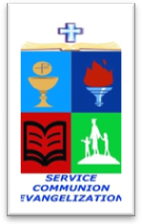
ROMAN CATHOLIC BISHOP OF NOVALICHES
EDUCATIONAL SYSTEM (RCBN-ES, Inc.)
Quirino Highway cor. P. dela Cruz St., Novaliches, Quezon City
Telephone 417-3105

POINTERS TO REVIEW IN SCIENCE 6
School Year 2017 – 2018

THIRD QUARTER

- Describing Forces
- Kinds of Forces
- Gravitational Force
- Frictional Force

- Energy: Its Forms and Transformation

- Types and Forms of Energy
- Uses of the Different Forms of Energy
- Transformation of Energy
- Simple Machines
- Safety in Handling and Using Simple Machines

